**ASSIGNMENT**

**SQL**

**Name :-** Prince Bansal

**Batch:-** ANP-D1544

**Student code :-** AF04955919

**Creating table**

CREATE TABLE employees (

emp_id INT PRIMARY KEY,

name VARCHAR(100) NOT NULL,

department VARCHAR(50),

salary DOUBLE, join_date DATE );

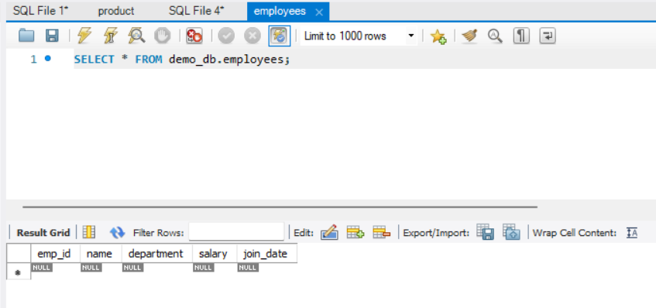

**Insert query**

INSERT INTO employees(emp_id, name, department, salary, join_date) VALUES

(101, 'John Doe', 'HR', 45000, '2021-06-15'),

(102, 'Jane Smith', 'IT', 75000, '2020-01-10'),

(103, 'Alice Johnson', 'Finance', 60000, '2019-08-23'),

(104, 'Bob Brown', 'IT', 80000, '2022-03-01'),

(105, 'Eve Davis', 'Marketing', 55000, '2021-11-05');

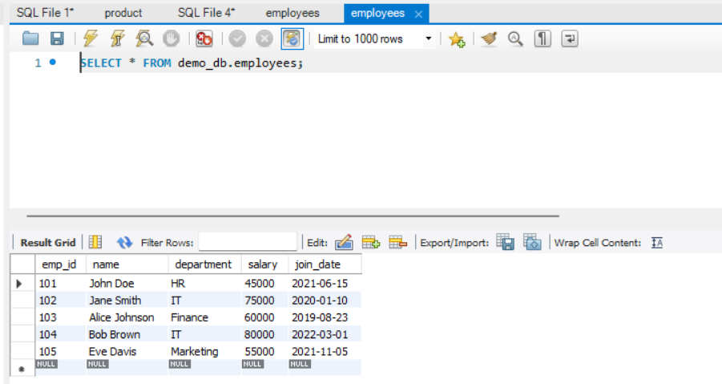

**Select Query**

SELECT * FROM employees;

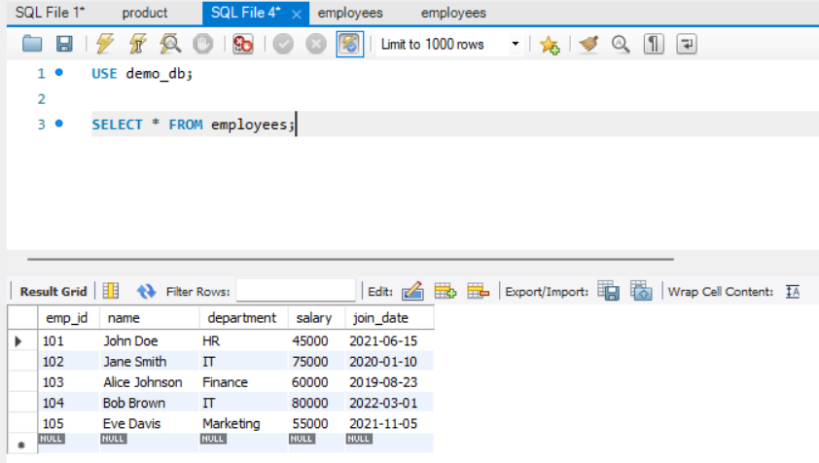

*SELECT name, department , emp_id FROM employees;*

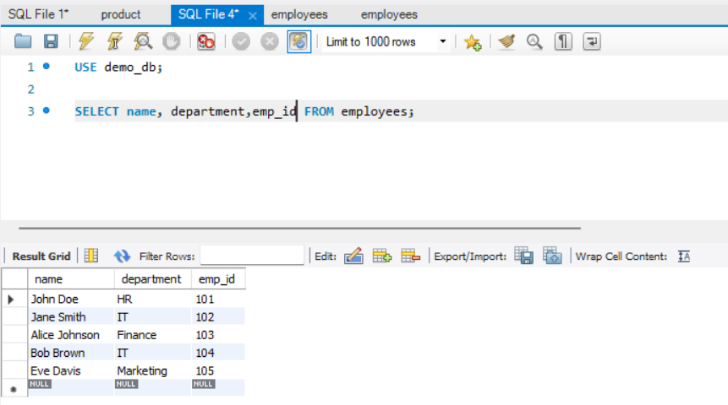

SELECT * FROM employees WHERE department = 'HR';

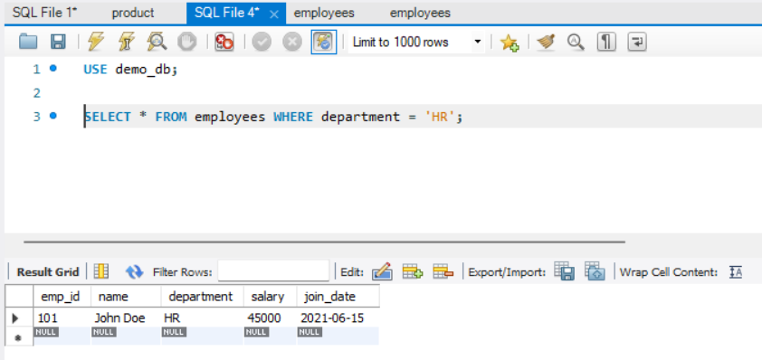

***AND, IN BETWEEN & LIKE***

*SELECT * FROM employees*

*WHERE department = 'IT' AND salary > 75000;*

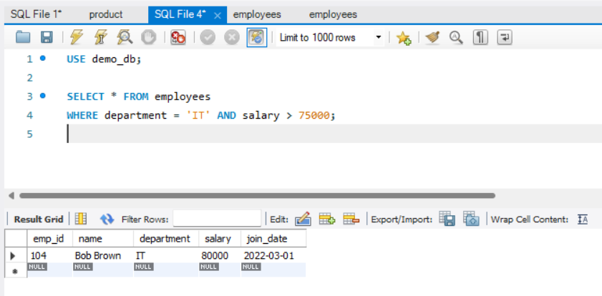

SELECT * FROM employees

WHERE department IN ('IT', 'Finance');

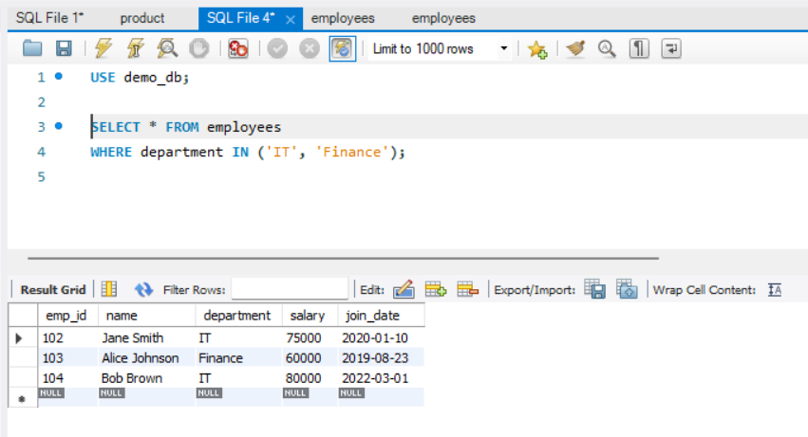

SELECT * FROM employees

WHERE salary BETWEEN 50000 AND 70000;

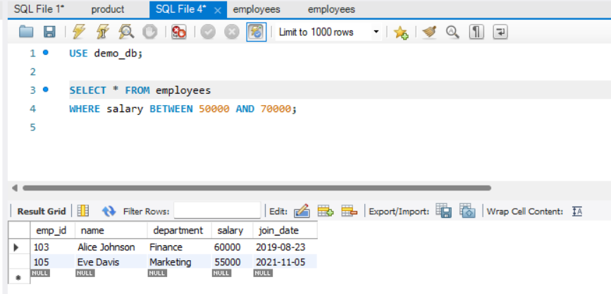

*SELECT * FROM employees*

*WHERE name LIKE 'J%'; -- Names starting with J*

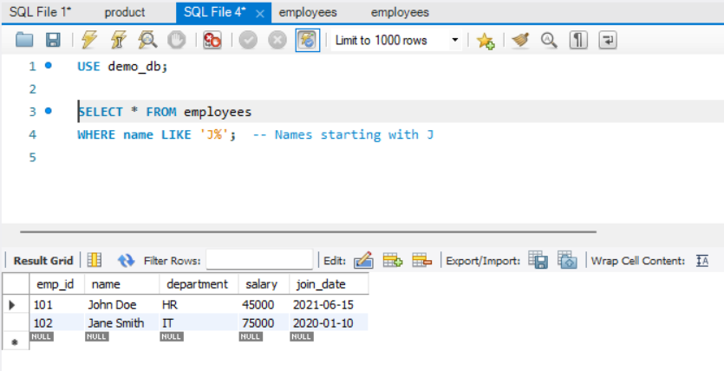

***CLAUSE -ORDER BY, WHERE, HAVING***

SELECT * FROM employees

ORDER BY salary DESC;

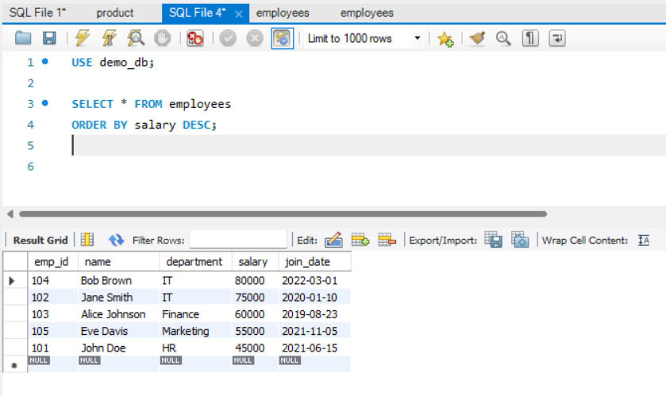

***UPDATE QUERY***

*UPDATE employees SET salary = 82000 WHERE emp_id = 104;*

